The Life Cycle of a Sea Turtle
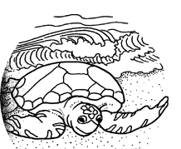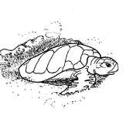
1. Female turtle arriving at the beach. 2. Digging nest
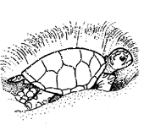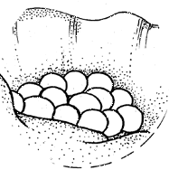
3. Laying eggs 4. Eggs in the nest
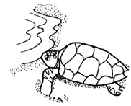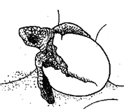
5. Turtle returns to water 6. Turtle hatching from egg
7. Hatchlings entering ocean 8. Young turtle searching for food in seaweed
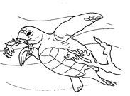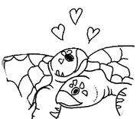
9. Young turtle eating a crab 10. Adult turtles mating

